### Yu Dafu [郁](http://search.books.com.tw/exep/prod_search_redir.php?key=%E6%B2%89%E6%B7%AA+%E9%83%81%E9%81%94%E5%A4%AB&area=mid&item=0010498736)達夫 (1896 – 1945?)

Yu Wen

Best regarded as a member of the vanguard of the ‘New Literature’ movement closely related to the nationalist May Fourth Incident in 1919, Yu Dafu was a distinguished figure in the Chinese literary scene of the 1920s and the 1930s. He was known especially for his explicit depictions of eroticism and sexuality. In 1921, towards the end of his sojourn in Japan, Yu published his first book through the Creation Society (創造社) (1921-1930), a literary organization he co-founded with like-minded friends who subscribed to similar romantic notions about literature. He went on to become a prolific writer of fiction, essays and classical poetry, an occasional translator, and an editor of several literary journals. Contending that ‘all literary works are autobiographies of their authors,’ his prose writings familiarized readers with his creative drive, as well as his peripatetic experiences in China and Japan, places that provide the setting for most of his fictional works. He spent the last eight years of his life in Southeast Asia (1938 – 1945?), first working as a newspaper editor, and later becoming a wanted fugitive during the Second World War. His career and life ended with his enigmatic disappearance in Sumatra, Indonesia, soon after Japan officially surrendered to the Allied Forces. He is believed to have been killed by the Japanese before their retreat. His body was never recovered. 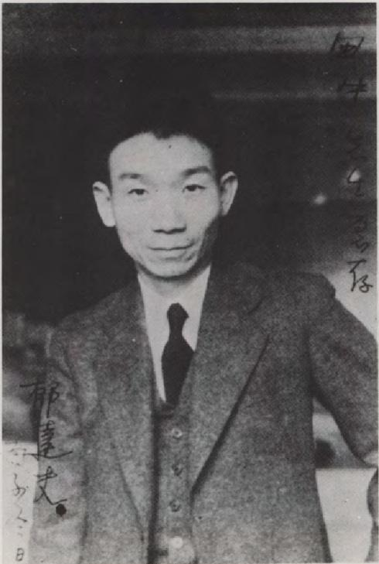

Born in the Fuyang county of the Zhejiang province in China and raised in a poor literati family, Yu (originally named Yu Wen) read widely in classical Chinese literature. His first creative works, published in China while he was an overseas student in Japan, were classical poems. Japan provided the initial foreign setting, as it did for many early twentieth century young Chinese intellectuals, where Yu absorbed Western literature voraciously. He claimed to have read around a thousand works of Russian, German, British, Japanese and French fiction in four years. In 1921, responding to ideas of a Chinese literary revolution, he started using the vernacular Chinese language to compose his first short story ‘A Silvery Grey Death’ [銀灰色的死]. It was included in *Sinking* (1921) [沉淪], his debut collection of fictional works. The collection also contains the eponymous short story now commonly acknowledged as Yu’s most significant contribution to the modern Chinese literary canon. ‘Sinking’ depicts a Chinese university student in Japan deeply troubled by his repressed sexual desire, whose actions give figuration to his profound sense of national failure, alleviated through masochistic self-torture. Reception of the controversial story was polarized. Some readers felt offended by the bold representations of erotic fantasies. Others gave him more credit for a veiled, underlying social critique against traditional morality.

Charges of immorality persisted and were fanned by his chequered personal life, which involved discontented marriages and extramarital affairs. Literary scholars have identified the diverse literary traditions that constitute Yu’s self-fashioning in both his life and works: he distills the confessional impulses of the Japanese ‘I-novel’, the character type of Turgenev’s ‘superfluous man’ (representative of nineteenth-century Russian fiction), and traces of Rousseau’s iconoclastic stance. What marks his sentimental fiction as modern is a focus on the protagonists’ desolate psychological landscapes and a signature style generally associated with decadence.

Yu’s legacy for modern Chinese literature spans a larger geographical breadth than is usually acknowledged. Treating Yu as a striking case study, literary scholars with visions beyond China have come to assess its implications for the Sinophone literary and cultural relationship between the mainland state and Southeast Asia. Yu was one of the most prominent Chinese writers to sojourn in the region.

**Change of Genre**

From 1934, Yu’s literary output shifted conspicuously from fiction to essays and classical poetry. During his limited residence in Malaya (comprising current day Malaysia and Singapore), he added a substantial body of current affairs commentaries to his writing profile, while demonstrating active cultural leadership. From managing several literary supplements for the newspaper *Sin Chew Jit Poh* [星洲日報], to establishing the China South Seas Society (中國南洋學會), a local academic association, to organizing anti-Japanese activities, he left an enduring legacy in the local Sinophone literary circles of the British colonies. His martyrdom in Indonesia augmented the sense of his connection to the mainland literary genealogy, an issue that has been widely debated.

Yu’s stature in Sinophone Southeast Asian literary history is not only attributed to the cultural and political footprints he left behind. Notably, his persona took on an almost mythical overtone after become a recurring character in the narratives of modern Malaysian Chinese fiction written by the Taiwan-based Malaysian literary critic, scholar-cum-writer Ng Kim Chew (黃錦樹). With different degrees of parodic emplotment, Ng incorporates Yu into several of his Borgesian short stories, using narrative devices such as fabricated literary events, [posthumous](http://www.nciku.com/search/en/posthumous) [manuscript](http://www.nciku.com/search/en/manuscript)s, footnotes, and academic research. Critics have pointed out the way Yu provides a persistent trope that allows Ng’s creative project to interrogate two interfacing literary histories and re-evaluate the enduring influence of China’s ‘New Literature’, from the early twentieth century, on Sinophone Malaysian literary production – thereby raising questions about the reach and purported impact of Chinese literary modernism.

**Bibliography**

Yu Dafu. Translated by Joseph Lau and C.T. Hsia. (1995) "Sinking" . In Joseph Lau and Howard Goldblatt, eds., *Columbia Anthology of Modern Chinese Literature*.

Lee, Leo Ou-fan. (1973) “Yu Ta-fu.” In *The Romantic Generation of Modern Chinese Writers*.

Shih, Shu-mei. (2001)"The Libidinal and the National: The Morality of Decadence in Yu Dafu, Teng Gu, and Others." In *The Lure of the Modern: Writing Modernism in Semicolonial China, 1917-1937*.

Tang, Xiaobing, and Michel Hockx. (2008) “The Creation Society (1921-1930)”. In Kirk Denton and Michel Hockx, eds., *Literary Societies of Republican China*.

Groppe, Alison. (2010) “The Dis/Reappearance of Yu Dafu in Ng Kim Chew's Fiction,” *Modern Chinese Literature and Culture*, vol. 22, no. 2.